**Exercise 1: Configuring a Basic Spring Application**

**Scenario:**

Your company is developing a web application for managing a library. You need to use the Spring Framework to handle the backend operations

**Code:**

**Pom.xml:**

<dependency>

<groupId>org.springframework</groupId>

<artifactId>spring-context</artifactId>

<version>5.3.34</version>

</dependency>

**ApplicationContext.xml:**

<?**xml** version=*"1.0"* encoding=*"UTF-8"*?>

<**beans** xmlns=*"http://www.springframework.org/schema/beans"*

xmlns:xsi=*"http://www.w3.org/2001/XMLSchema-instance"*

xsi:schemaLocation=*"*

*http://www.springframework.org/schema/beans*

*http://www.springframework.org/schema/beans/spring-beans.xsd"*>

<**bean** id=*"bookRepository"* class=*"com.library.repository.BookRepository"*/>

<**bean** id=*"bookService"* class=*"com.library.service.BookService"*/>

</**beans**>

**App.java:**

package com.cognizant.LibraryManagement;

import com.library.service.BookService;

import org.springframework.context.ApplicationContext;

import org.springframework.context.support.ClassPathXmlApplicationContext;

public class App {

public static void main(String[] args) {

System.***out***.print("This is a Maven Project");

}

}

**Exercise 2: Implementing Dependency Injection**

**Scenario:**

In the library management application, you need to manage the dependencies between the BookService and BookRepository classes using Spring's IoC and DI.

**Code:**

**BookService.java:**

package com.library.service;

import com.library.repository.BookRepository;

import java.util.List;

public class BookService {

private BookRepository bookRepository;

public void setBookRepository(BookRepository bookRepository) {

this.bookRepository = bookRepository;

}

public void printBookList() {

List<String> books = bookRepository.getBooks();

System.***out***.println("Books in Library:");

for (String book : books) {

System.***out***.println("- " + book);

}

}

}

**BookRepository.java:**

package com.library.service;

import com.library.repository.BookRepository;

import java.util.List;

public class BookService {

private BookRepository bookRepository;

public void setBookRepository(BookRepository bookRepository) {

this.bookRepository = bookRepository;

}

public void printBookList() {

List<String> books = bookRepository.getBooks();

System.***out***.println("Books in Library:");

for (String book : books) {

System.***out***.println("- " + book);

}

}

}

**App.java**

package com.cognizant.LibraryManagement;

import com.library.service.BookService;

import org.springframework.context.ApplicationContext;

import org.springframework.context.support.ClassPathXmlApplicationContext;

public class App {

public static void main(String[] args) {

System.out.print("This is a Maven Project");

ApplicationContext context = new ClassPathXmlApplicationContext("applicationContext.xml");

BookService bookService = context.getBean("bookService", BookService.class);

bookService.printBookList();

}

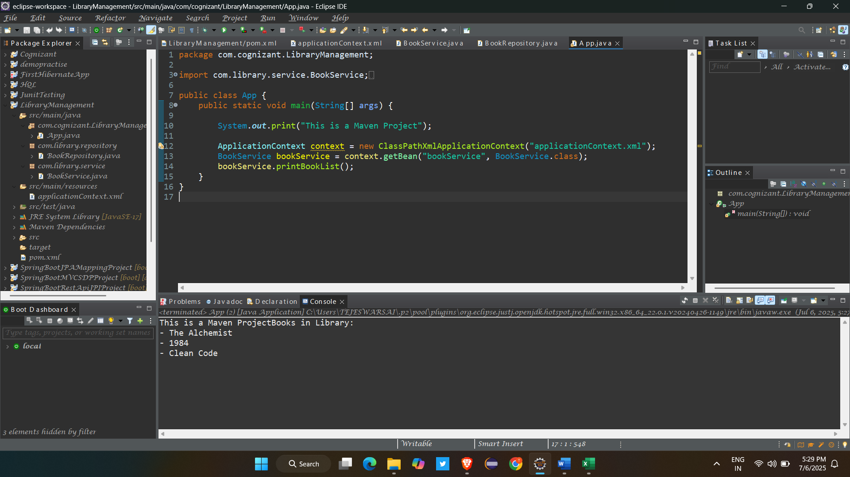

**Exercise 4: Creating and Configuring a Maven Project**

**Scenario:**

You need to set up a new Maven project for the library management application and add Spring dependencies

**Code :**

**Dependencies:**

<dependency>

<groupId>org.springframework</groupId>

<artifactId>spring-context</artifactId>

<version>5.3.34</version>

</dependency>

<dependency>

<groupId>org.springframework</groupId>

<artifactId>spring-aop</artifactId>

<version>5.3.34</version>

</dependency>

<dependency>

<groupId>org.springframework</groupId>

<artifactId>spring-webmvc</artifactId>

<version>5.3.34</version>

</dependency>

**Plugins :**

<plugin>

<artifactId>maven-compiler-plugin</artifactId>

<version>3.13.0</version>

</plugin>

